DESIGN OF INTERACTIVE COURT LINES FOR SPORTS

USING LED’S

MUHAMMAD ARIF AIMAN BIN MAZLAN

SITI HAJAR MUNIRAH BINTI KAMARULZAMAN

INTAN NUR FATIHA BINTI SAAHARI

SEMESTER 2

SESSION 2021/2022

DEPARTMENT OF INFORMATION TECHNOLOGY

UNIVERSITY TUN HUSSEIN ONN MALAYSIA

DESIGN OF INTERACTIVE COURT LINES FOR SPORTS USING LED’S

MUHAMMAD ARIF AIMAN BIN MAZLAN

SITI HAJAR MUNIRAH BINTI KAMARULZAMAN

INTAN NUR FATIHA BINTI SAAHARI

Project report submitted

In Fulfilment of the Requirements for the

Diploma in Information Technology

Department of Information Technology,

Centre for Diploma Studies,

University Tun Hussein Onn Malaysia

JUNE,2022

**AUTHORS APPROVAL**

We hereby declare that this project report entitled is completely original from our own individual work except for the references that we used in our report. This report is created in accordance with the requirements of the Department of Information Technology, Centre of Diploma Studies, University Tun Hussein Onn Malaysia's Final Year Project (UTHM). The cognitive contents of this report are based on research done by numerous sources for us to utilise as advice and from our supervisor to oversee in order to develop and increase the overall quality of the project report.

If we violate any of the conditions stated in the Final Year Project regulations, all work of this project will be rejected and penalized and will be considered as failing to complete the Diploma studies.

|  |  |
| --- | --- |
| Author’s Name | : MUHAMMAD ARIF AIMAN BIN MAZLAN |
| Signature | : |
| Author’s Name | : SITI HAJAR MUNIRAH BINTI KAMARULZAMAN |
| Signature | : |
| Author’s Name | : INTAN NUR FATIHA BINTI SAAHARI |
| Signature | : |
| Course | : DIPLOMA FINAL YEAR PROJECT |
| Department | : DEPARTMENT OF INFORMATION TECHNOLOGY |
| Faculty | : CENTRE FOR DIPLOMA STUDIES (CeDS) |
| Project Title | : AUTO-GENERATED LINE COURT FOR SPORTS |
| Date | : |

**SUPERVISOR APPROVAL**

I hereby verify that I have read this thesis report and every information that contained in this report is true and meet the Final Year Project of the Information technology Department’s requirements in terms of scope, quality of the report and also the regulations of the Final Year Project from the Department of Information Technology, Centre of Diploma Studies, University

Tun Hussein Onn Malaysia for the purpose of fulfilment of the requirements for the Diploma of Information Technology.

|  |  |
| --- | --- |
| Supervisor Name | : Ts. Dr. SHELENA SOOSAY NATHAN |
| Signature | : |
| Date | : |

**ACKNOWLEDGEMENT**

This research was made possible because of the motivation and help from our friends who were there from scratch for this project until it's completed. We really appreciate their support, motivation and advice while completing the Design of Interactive Court Lines for Sports using LED’s project. Thank you for giving ideas and thought in order for us to improve the quality of our project so that it would be more beneficial. We also want to thank to those who lend a bit of their time to answer the project survey for the evaluation. We highly appreciate it.

We also would like to express sincere gratitude to our supervisor which is Ts. Dr. Shelena Soosay Nathan for the consistent support and assistance throughout the entire project session. Also, we further states thanking the Edu Hub Pagoh professionals in participating and evaluate this study. We also wish to thank the Centre for Diploma Studies, University Tun Hussein Onn Malaysia for giving the chance to do this research.

Last but not least, we would like to convey our heartfelt appreciation to everyone who has contributed and provided their assistance, both directly and indirectly, during the project. Hopefully, this study being useful and helpful to motivate people to explore more about the latest technology such as Internet of Things.

## ABSTRACT

Sport activity has become a norm in our daily life because of the importance of sport that benefits our health. The current traditional sports culture halls have various flaws, resulting in waste of space resources. People just play specific different sports everyday which results in a huge waste of space. This study provides a solution which is to develop an auto-generated line court. This project is targeted for kids, adults and citizens of all kinds or groups of people. The study uses the Input Process Output (IPO) method which acts as a guideline throughout the development of this project. There are several hardware components that were used in developing this project which are Arduino UNO, P10 LED, HC-05 Bluetooth module, DMD Connecter, Jumper wires for building the prototype of this project. Arduino IDE and MIT apps are used as a software that generates the codes to control overall programs and build the interface for users to interact. After the testing was conducted, all of the components and software have reacted as intended which produces the desired result which is the desired court’s line with selected choice. The multiple line that is produced in a surface has proven that the Design of

Interactive Court Lines for Sports using LED’s project is useful and efficient to be used by the target group. In future, this project can be used by people to play different sports in a hall so that it is not wasting the spaces. This project will add new features as for the improvement so that it will be more efficient and innovative that could help to ease and encourage people in doing sports.

**ABSTRAK**

Aktiviti sukan telah menjadi kebiasaan dalam kehidupan seharian kerana kepentingan sukan yang memberi manfaat kepada kesihatan kita. Dewan budaya sukan tradisional semasa mempunyai pelbagai kelemahan, mengakibatkan pembaziran sumber ruang. Orang ramai hanya bermain sukan yang berbeza setiap hari yang mengakibatkan pembaziran ruang yang besar. Kajian ini menyediakan penyelesaian iaitu membangunkan gelanggang talian yang dijana secara automatik. Projek ini disasarkan untuk kanak-kanak, orang dewasa dan rakyat semua jenis atau kumpulan orang. Kajian menggunakan kaedah Input Process Output (IPO) yang bertindak sebagai garis panduan sepanjang pembangunan projek ini. Terdapat beberapa komponen perkakasan yang digunakan dalam membangunkan projek ini iaitu Arduino UNO, P10 LED, modul Bluetooth HC-05, DMD Connecter, Jumper wires untuk membina prototaip projek ini. Aplikasi Arduino IDE dan MIT digunakan sebagai perisian yang menjana kod untuk mengawal keseluruhan program dan membina antara muka untuk pengguna berinteraksi. Selepas ujian dijalankan, semua komponen dan perisian telah bertindak balas seperti yang diharapkan yang menghasilkan keputusan yang diingini iaitu garisan mahkamah yang dikehendaki dengan pilihan yang dipilih. Garisan berbilang yang dihasilkan di permukaan telah membuktikan bahawa Reka Bentuk Garisan Gelanggang Interaktif untuk Sukan menggunakan projek LED berguna dan cekap untuk digunakan oleh kumpulan sasaran. Pada masa hadapan, projek ini boleh digunakan oleh orang ramai untuk bermain sukan yang berbeza di dalam dewan supaya ia tidak membazirkan ruang. Projek ini akan menambah ciri-ciri baru sebagai penambahbaikan supaya lebih cekap dan inovatif yang boleh membantu memudahkan dan menggalakkan orang ramai bersukan.

**LIST OF CONTENTS**

**CHAPTER CONTENTS PAGE**

AUTHOR’S DECLARATION iii

SUPERVISOR’S DECLARATION

iv

ACKNOWLEDGEMENT

v

ABSTRACT

vi

ABSTRAK

vii

LIST OF CONTENTS viii

LIST OF TABLES xi

LIST OF FIGURES xii

LIST OF APPENDIX xiii

CHAPTER 1 INTRODUCTION 1

1.1 Background 1

1.2 Problem Statement 2

1.3 Objectives 4

1.4 Scopes 4

1.5 Significance of Project 4

1.6 5

Conclusion

CHAPTER 2 LITERATURE REVIEW 6

2.1 Introduction 6

2.2 Internet of Things (Iot) 6

2.3 Internet of Things Technologies 7

2.3.1 Near Field Communication (Nfc) 8

2.3.2 Bluetooth Low Energy 8

2.4 Internet Of Things Uses 8

2.4.1 Smart Home 9

2.4.2 Smart Scoreboard System 10

2.4.3 Sensors 10

2.5 Design of Led’s for Interactive Court Lines 11

2.6 Android Score Board Led Matrix P10

Application Based On Arduino Stm32 12

Android Control

2.7 Design of Automation System to Control

The Brightness Of Led Using Arduino Uno 12 and Iot

2.8 Iot Based Message Scrolling Led Display 13

2.9 Project Comparison 14

2.10 The Evolution of Sport Court 17

2.10.1 Study on Developed Auto Generated Line

18

Court

2.11 Conclusion 19

CHAPTER 3 RESEARCH METHODOLOGY 20

3.1 Introduction 20

3.2 Input Process Output (IPO) Methodology 20

3.2.1 Input 21

3.2.2 Process 22

3.2.3 Output 24

3.3 Conclusion 25

CHAPTER 4 PROJECT DEVELOPMENT 26

4.1 Introduction 26 4.2 Project Hardware 26

4.3 Arduino UNO Code Developing 27

4.4 MIT Application 30

4.5 Sports Court Model 31

4.6 Conclusion 32

CHAPTER 5 RESULT AND DISCUSSION 33

5.1 Introduction 33

5.2 Testing 33

5.3 Discussion 40

5.4 Conclusion 41

CHAPTER 6 RESULT AND DISCUSSION 42

6.1 Introduction 42

6.2 Project Achievement 42 6.3 Project Constraints 43

6.4 Project Improvement 44

6.5 Conclusion 45

REFERENCE 46

APPENDICES 49

## LIST OF TABLES

Table 1: Differences between the existing projects 14

Table 2: Item list 31

Table 3: Result according to the item and function 33

Table 4: Result according to the button and output 36

### LIST OF FIGURES

Figure 1: Conventional sport court 17

Figure 2: Auto Generated Line Court 17

Figure 3: Input-Process-Output Methodology (IPO) 21

Figure 4: Meeting with higher ups Pagoh Education Hub 22

Figure 5: Circuit Diagram 23

Figure 6: The library, variable declaration, and function. 28

Figure 7: Arduino codes scripts sports 29

Figure 8: Arduino codes scripts 29

Figure 9: MIT codes 30

Figure 10: Application interface 31

Figure 11: Product prototype 32

Figure 12: Connectivity between bluetooth and application 35

Figure 13: Bluetooth Responds: “Not Connected” 35

Figure 14: Bluetooth Responds: “Connected Successfully” 35

Figure 15: Bluetooth Responds: “Disconnected” 39

Figure 16: Meeting with higher ups for testing 39

Figure 17: Feedback via google form 39

## LIST OF APPENDICES

Table A.1: Gantt Chart 49

Table B.1: Feedback Evaluation Survey Form 50

Table C.1: Product Cost Table 55

**CHAPTER 1**

**INTRODUCTION**

## 1.1 Background

From the early centuries until the current millennium era of ours, sport has become somewhat a norm in our every day’s life. Sport can be defined as a human activity which is generally related to physical movement either in a group or individually (G. Sage, 1988). Sport can be performed by all ages depending on what type of sport it is. In the United Kingdom, their government voiced out to the citizens to practice two hours of physical activities in a week, within and outside of school days, highlighting the importance of sports for health (DCMS, 2000). Sport activities can be performed anytime if one has sufficient free time to spend on sport activities. Sport court is what comes to mind when thinking of performing sport acting as the guidance while performing sport activity. From a scientific standpoint as well as in terms of the health elements of sports, the safety of sport venues is critical to their effective use (A. Alizadeh, 2019). Construction and preservation of sports areas for higher progress and successful attraction of sport fans and athletes at higher levels is very important from a safety standpoint, and it proves that sporting stadiums must have in line safety parameters during activities and in good physical condition to avoid negative consequences and, ultimately, create a safe place to work out and practice (A. Alizadeh, 2019).

With how the technology evolved and improved, it is easily said that most accommodation or tools that we use have Internet of Things (IoT) embedded. The IoT paradigm allows low-resource devices to interact in a completely flexible and widespread manner, and the data collected from these devices is utilized to make decisions in important applications such as traffic infrastructure, health care, and home security, to mention a few (S. Moore, 2020). This encourages more ideas that implement IoT as its core. Thus, we proposed a court that uses IoT to communicate with it, naming the project Auto-Generated Court Line for Sports. The project will focus on the court generating automatic court lines for the specific sports that were chosen. The lines are made up of light-emitting diode (LED) lights and the surface will be shock-absorbing material such as tempered glass used in basketball backboard or the squash court glass. The surface will be laminated later to make it darker to avoid the dispersion of light, making the line shape sharper and more vivid to naked eye. The court will be implemented in a closed hall to allow maximum lumination of light and avoid unpredictable weather. All of this will be triggered from the user’s smartphone via Bluetooth, implementing the IoT principle.

## 1.2 Problem statement

The issues with sport courts that are considered as inconvenience is the large scale area used to create several sport courts which takes up a lot of space. People's preferences for sporting venues are influenced by their age, money, leisure time, and consumption level (Jiang, R, & Li, Y. 2020). The current traditional sports culture halls have various flaws, resulting in waste of space resources (Jiang, R., & Li, Y. 2020). Soccer, basketball, baseball, cricket and table tennis are among the most popular, although there are some 300 sports in the world (David G. McComb, 1999). This makes it a huge waste because they just play specific different sports everyday. There are a variety of sports facilities that have already been provided. Hence, that facilities became a waste because people choose to play the same sports in their daily life. This project is designed to allow players to play many sports in a hall so that the space that is used to build facilities is used as it best.

Next issue will be the cost of building and maintaining the court. The cost really plays a role in developing IoT. Low cost is the main driver in the development of new designs and technologies for IoT and the tendency is to stay at established (older) technologies which are less expensive and have high yields (Marinissen et al., 2016). In the meantime, Energy conservation and sustained maintenance and repair costs must also be taken into consideration (Onubi, 2015). Different sports courts that are built in many or different places consume a higher energy and cost in maintaining the court since it needs to fix many courts. Hence, the proper building and maintaining the sports court is very important from the start since it can reduce the cost. It could be said that with proper maintenance culture, a facility will last longer, provide a healthier and safer environment, be less costly, and provide a more satisfying experience for user groups (Bugaj & Kosiński, 2018).

Besides that, unpredictable weather also becomes one of the issues that are taken into consideration. Certain sports in general need to be played in an enclosed space such as a hall to prevent any sort of environmental factors. Indoor sports facilities, such as sports halls and squash courts, have recently become more plentiful (J. Thornes, 1977). Regardless, even with the increase of indoor sports facilities, there are housing areas and universities that still implement cement or hard courts in an open area which is easily affected by unpredictable weather conditions. Most injuries occur in hot and humid weather, cold weather, and wet and rainy weather. The harm may not be immediate, but rather the result of the body's weakening due to the harsh weather circumstances (V. Lakshmana Rao, 2021). The project is proposed to be constructed within a closed hall to overcome unpredictable weather problems. Therefore, the author considered developing this project that is Auto-Generated Court Line for Sports to overcome these problems and such bring benefits to the community.

## 1.3 Objective

1. To Identify the requirements for smart sports court.
2. To develop an auto-generated line court.
3. To evaluate the usefulness of the auto-generated line court

## 1.4 Scopes

The target user of this project is for kids, adults and citizens of all kinds or groups of people. This sports court is good for those who want to get a healthy life, release stress or just have fun. This Auto Generated line court provides few sports courts like badminton, basketball, futsal and tennis. Besides, this sport court is suitable for kids that are age nine and above since the material of the court surface is made from security glass that is safe and it can reduce injuries if the player falls. Moreover, this court is built in a specific place which is built in a closed hall in order to avoid any environmental factors and save in terms of maintenance cost and space. Apart from that, the target platform of this project in terms of operating system (OS) and hardware is this project use Android operating system on mobile phones or smartphone only because the requirement in order to use this court is a smartphone because people need to have this court's app on their smartphone to choose sports and connect to the courts from their smartphone. The features of the court are that the court can be connected to a smartphone via bluetooth and the app of the court has an easy and simple interface for the users to use.

## 1.5 Significance of project

This Auto-Generated Line Court gives many significances for people to play sports such as this Auto-Generated Line Court will become more useful and easier to use because people can play different sports at one place only and people are able to choose different kinds of courts and games that they want by using an application on smartphone. For example, users can simply touch the button directly from their smartphone and the line of the court will light up based on the chosen sport. Besides, this IoT indoor court is safer because this sport court is using tempered glass in which it can reduce injuries rather than a court that has sand, small stones or hard surfaces. Other than that, this Auto-Generated Line Court can save more time since people don't have to go to different places to play different sports. So, they are able to play sports freely without thinking about the defective court or injuries.

## 1.6 Conclusion

In conclusion, this project will produce a new model of sports court which is able to give many benefits for people to play sports and encourage them. This project will benefit in terms of cost because it mainly focuses on a place compared to the traditional way that takes much more space. Besides, this Auto-Generated Line Court will become more useful and easier to use because people can play many different sports in one place by changing the line of court by only pressing the button. Also, this indoor court is safer because our sports court is using security glass which can reduce injuries. In the meantime, this court also can save time when people do not have to go to different places to play different sports. So, people can play sports freely without thinking about the defective court or injuries.

**CHAPTER 2**

**LITERATURE REVIEW**

## 2.1 INTRODUCTION

This chapter explores the evolution of smart sport courts which propose a better way to minimize the usage of space and the ability to perform sports in any weather condition. The sport court was set up with LED and Bluetooth Module to enable an interaction between the user’s smartphone and the smart court. When a user’s smartphone is connected via Bluetooth with the Bluetooth Module of the smart court, the user will have the access of choosing multiple options of the sport they want to play in the smart court app, thus reflecting the outcome onto the LED, creating a complete court line. This Millennia era, the non-stop development of technology has offered many benefits towards sports in general. For example, football fields are implemented with Goal-Line Technology (GLT) which will allow referees to view certain moments that are hard for eyes to catch during an official match. Smart court was one of the inventions of the IoT that is related to development and production that are connected to a network that is Bluetooth. Two main benefits of the smart court are it helps to save spaces that are usually being used for multiple sport courts and lowering the cost of traditional courts as a whole. This chapter ventures more into the invention and innovation of the smart court.

## 2.2 INTERNET OF THINGS (IoT)

The Internet of Things (IoT) is considered one of the most important revolutionary pieces of technology that pushes the boundaries of usability and application in this modern world. It helps in creating a virtual environment that has already been used in each corner of the world, for instance the smart home system. The Internet of Things (IoT) is a goal and ambition to bring the internet into the real world by embracing everyday objects (M. Asghar, 2015). All physical objects that have the ability to perform connectivity with a network or internet such as server, smartphone, computers, sensors that use “small computers” and interact with each other via the network that they were connected to. Physical devices were no longer isolated from the virtual world. They may be operated remotely from any location, and the capability of the device or physical object can act as a physical access point to the internet service provider (M. Asghar, 2015). The Internet of Things (IoT) paradigm allows low-resource devices to interact in a fully flexible and widespread manner, and the data collected from these devices is utilized to make decisions in important applications such as traffic infrastructure, health care, and home security, to mention a few (S. Moore, 2020). The attention that IoT gained for the past years is due to its convenience of maneuvering multiple devices with less effort through the internet or network and without needing human interaction in between just like Arduino. Arduino is also one of the

IoT component that attract people’s attention. As defined on their website2 “Arduino is an open- source electronics platform based on easy-to-use hardware and software”. It has the advantages of low cost, cross-platform, simplicity of programming, and open-source extendable software and hardware. Arduino products are based on the 8-bit ATmega microcontrollers. Boards are equipped with a large number of digital and analog IO pins, serial communication modules, USB connection, and ICSP capability (El-Abd, 2017). The microcontrollers are typically programmed using a dialect of features from the programming languages C and C++ (Kakade et al., n.d.-a, 2018). Thus, the Arduino Mega, Arduino Nano, and Arduino UNO board (models) are frequently used to control microcontroller boards in systems (Kakade et al., n.d.-b, 2018). So, that is the meaning of Arduino which also gives a big uses in IoT.

## 2.3 INTERNET OF THINGS TECHNOLOGIES

The development of IoT is affected by the technical part of the innovation that can be unpredicted. When a large number of smart virtual or physical objects are connected to a large database and network, a simple, effective, and low-cost system is required for item identification (Ji Chun et al., 2010). For the invention to work, a connection between the user and the invention has to be established. Bluetooth technology was used in this invention to create a connection between the invention and the user’s device for controlling the desired outcome. The technology essentials of IoT are embedded intelligence, nanotechnology and a network for it to connect with other devices. The Internet of Things product was created by combining all of these technologies (Ji Chun et al., 2010). The product will become more compact, thus the usage of embedded intelligence with sensors has to be more efficient and have the ability to connect and interact.

### 2.3.1 NEAR FIELD COMMUNICATION (NFC)

Near field communication (NFC) enables short-range wireless data transfer between devices. This NFC technology is required for the Internet of Things to build a connection network amongst all devices. NFC allows devices to communicate with one other in order to make contactless payments (Antonio et al., 2018). However, the NFC mechanism can only communicate over a limited distance. As a result, the gadgets must be put close together.

### 2.3.2 BLUETOOTH LOW ENERGY

The Bluetooth Low Energy (BLE) was created with the goal of reducing power usage and latency for basic data transfers. Although Near Field Communication may also be used to send function data between devices, it is confined to a relatively small distance. Furthermore, when a large number of devices are linked to a network, the power consumption is quite high. BLE was used to alleviate these two difficulties (Albert F.Harris et al., 2016). BLE devices frequently go into "sleep mode" until an event happens.

## 2.4 INTERNET OF THINGS USES

The Internet of Things is now widely used across the world since it offers greater convenience and advantages to people's daily lives. Monitoring and tracking, agriculture, catastrophe detection, and other industries are examples of where IoT has previously been used (Ji Chun et al., 2010). For an instance, most of IoT products use Arduino as a main component in order to make the product greatly function. Over the years, Arduino has been the brain of thousands of projects, from everyday objects to complex scientific instruments (Zlatanov, n.d., 2015). Arduino has been used a lot in IoT projects such as robotics, programming and many more. IoT is a concept that aims to expand the benefits of continuously being in internet connectivity (Yusro et al., 2021). Arduino was easy to run and use the program. The Arduino software is easy-to-use for beginners, yet flexible enough for advanced users (Zlatanov, n.d., 2015). digitalRead(), digitalWrite(), Serial.begin() are one of the Arduino code functions. In order to set electrical components into I/O mode, the user may also define their digital and analogue pins. Arduino technology is low-cost and compatible with a variety of operating systems, including Windows, Macintosh, and Linux (Jiun Ying Lim Xin Woei Lim Hui Wen, n.d., 2020). Arduino is capable of interacting with buttons, multi-sensors, motors, speakers, global positioning system (GPS), cameras, liquid-crystal display (LCD) screens, and nowadays many uses smartphones for remote control (Yusro et al., 2021). The Arduino platform in IoT is becoming increasingly popular among new users even for advanced users because it’s simple, easy and not complicated to use. Not impossible for people to use Arduino in order to make better and more excellent projects in the future.

### 2.4.1 SMART HOME

Further research into development of technology has led to the creation of IoT based technology, namely the Smart Home. Smart Home gives the ability to the user interaction with devices that are embedded with tiny computers within their house. These electronic devices interacting with each other via a network are controlled by an application so that users can configure and give orders to these devices even from a far distance. Leviton enables homeowners to create a smart and safe living environment while also providing a comfortable and convenient lifestyle (Punit & Jasmeet, 2016).

For smart court projects, it used the same principle as Smart Home which is connection to a network for interaction. Both Smart Home and the smart court project uses either the Internet or Bluetooth. Smart court uses Bluetooth for connectivity. With this, the court can be controlled by the user via their smartphone, enabling a faster and convenient experience.

### 2.4.2 SMART SCOREBOARD SYSTEM

Smart scoreboard system which is controlled by Arduino is used to maximize the scoreboard control activity to its optimum (M. Sungkar, 2019). Light Emitted Diode (LED) based matrix displays are used as an information board because of its very high power and capable of being programmed for featuring interesting animations. The smart scoreboard system uses Arduino as their microcontroller and LED as their output device, creating a smart ecosystem that benefits the user.

The similarity that the smart scoreboard system shared with the smart court project is it is programmable to perform complex operation and output an interactive and interesting display. For example, both project uses can be controlled by the user without any manual operation. This is because the project is being controlled by a microcomputer, which in this case Arduino. Both of these projects also give a clear visibility of the desired output by using the LED display.

### 2.4.3 SENSORS

Sensors are an integral component of automotive electronic control systems. Sensors are defined as “devices that transform (or transduce) physical quantities such as pressure or acceleration (called measurands) into output signals (usually electrical) that serve as inputs for control systems.” (Fleming, 2001). Sensors are also one of the IoT components that is controlled by Arduino. There are various sensors out there such as motion sensors, temperature sensors, vibration sensors, humidity sensors, vision sensors and many more. Sensors are able to upgrade people’s lives or any other environment that gives a modern and simple life. An instance, smart garbage alert system using Arduino UNO (Sathish Kumar et al., 2016). This IoT product had a smart alert system for garbage clearance by giving an alert signal to the municipal web server for instant cleaning of dustbin with proper verification based on level of garbage filling. This IoT product using ultrasonic sensor which used Arduino UNO to check the level of filled garbage in the dustbin then sends the alert to the municipal web server once if garbage is filled (Sathish Kumar et al., 2016). This example shows that sensors are able to give the desired output for users.

**2.5 DESIGN OF LED’S FOR INTERACTIVE COURT LINES.**

The IoT design of LED’s for interactive court lines were controlled by LED, Arduino Mega 2560, RFID and sensors such as pressure sensor and IR sensors. This project proposed an efficient system design by providing security and quick access to multiple games at the same location. The distinct court rule lines shown for various sports like basketball, badminton, volleyball and kabaddi were set up and stored in the Application through which one can select particular court of interest (Sunil Kumar et al., 2020). The uses of pressure sensor and IR sensor are for referees to monitor the score points which helps the player and the referees as well like IR will detect and increase the score point when the basketball get into the target. To connect, the RFID module should be scanning the tag first and if the tag is matched the screen will shows

“Tag Matched” then the password needs to be filled in order to access the court. If the password is valid then the screen displays “Pass Accepted”. This will triggered the BMP180 sensor which it could read the temperature and pressure. We can update the scores while being in the game by using two method which is manually using the buttons that provided at the side court or a sensor named IR sensor itself will automatically update the scores. This project also using the Blynk application for user. Making the task easier for the user to select the button in which each button provides function like the selection of sports court, On and Off button and Servo (Sunil Kumar et al., 2020).

The project was pretty similar with Auto Generated Line Court as Auto Generated Line Court also use LED and Arduino as it also did a line court for sports but the difference is different type of Arduino used which is Auto Generated Line Court use Arduino UNO rather than Arduino Mega because the Auto Generated Line Court was just to show the line court for different game at one space which it didn’t required a large code, memory and storage space. Hence, the LED’s for interactive court lines project used Arduino Mega because the project had a lot of functionality and required a larger code.

**2.6 ANDROID SCORE BOARD LED MATRIX P10 APPLICATION BASED ON ARDUINO STM32 ANDROID CONTROL.**

The IoT based Android Score LED Matrix P10 application is based on Arduino STM32 android control. This project used for sport like in sport competition to determine the victory by refer to the points from the android score board rather than adding the point manually (Sungkar & Albab, 2019). This project used and controlled by Arduino STM32 and LED Matrix to display the running text. In order to make the score board functional, this project developed an Android application using MIT application. There are several of sports like basketball, volleyball, badminton, football and futsal in which every game has different rules and time. When user click the button, the data will be sent to Microcontroller Arduino via bluetooth in order to process and to display the time and score at the LED Matrix display.

The Android Score LED Matrix P10 application had a similar function with Auto

Generated Line Court like Auto Generated Line Court also display line using LED, used Arduino as the main board and had an application using MIT app as well but different in terms of types of LED and Arduino. Auto Generated Line Court have the same concept like Android Score LED Matrix P10 application project.

**2.7 DESIGN OF AUTOMATION SYSTEM TO CONTROL THE BRIGHTNESS OF LED USING ARDUINO UNO AND IOT.**

This design of automation system is a system to control the brightness of LED for less power consumption and reduce heat for increasing the lifetime. This project uses an intensity-controlled system which lowers the intensity when there is no one in the vicinity and increases the intensity when there is the presence of individuals in the surrounding and also control the lights anywhere in the system (Jeyavinotha et al., 2019). This system provides four features which is Automatic On/Off bulbs based on surrounding light intensity, adjust the brightness when the motion is detected, able to control the lights remotely and able to detect the faulty lights. This system is controlled by Arduino Uno, IR sensor to sensor the movement, Light Dependent Resistor (LDR) sensor and resistors. The brightness of the light can be controlled by mobile phones. This project is achieved a desired output like reduce the power consumption (Jeyavinotha et al., 2019).

This project had the same concept with the Auto Generated Line Court in terms of controlling the product remotely via mobile phone. Also, both projects have developed an application and it needs to connect the application to the Wi-fi or bluetooth in order to function. For Auto Generated Line Court project used MIT application instead of Blynk and also using bluetooth to connect the court as well.

**2.8 IOT BASED MESSAGE SCROLLING LED DISPLAY.**

This IoT based message scrolling LED display is to replace conventional analog type notice board with digital notice board to make an information dissemination much easier in a paperless community (Surendiran et al.,2020). This message scrolling LED display project use Arduino Uno as a main controller to connect from the computer to dot-matrix display by using a usb cable or power with an AC-to-DC adapter or battery to get started. and it use dot-matrix to display the moving message. The operation is by sending message from any remote area to the distant located e-notice board using GSM mobile in order to display the message in dot-matrix. In order for GSM to function, GSM modem need a phone SIM card to operate the data

(Surendiran et al.,2020).

The difference between message scrolling LED display and Auto Generated Line Court was the types of LED. The IoT based message scrolling LED display used a dot-matrix display which a flat led matrix surface while Auto Generated Line Court prototype using P10 DIP LED in which it much more suitable in creating design like shapes, as a message board and many more functions that can be do using this type of LED rather than dot-matrix which have a limited function to display.

## 2.9 COMPARISON BETWEEN EXISTING PROJECTS

# Table 1: Differences between the existing projects.

|  |  |  |  |  |  |
| --- | --- | --- | --- | --- | --- |
| **PROJECT** |  | **FEATURES** |  | **ADVANTAGES** | **DISADVANTAGES** |
| (i) DESIGN OF  LED’S FOR  INTERACTIVE  COURT LINES    (Sunil Kumar et al., 2020). | 1.    2.    3.    4. | Use RFID as an electronic key tag to access the sport court.  Use Arduino Mega  2560 as a connection to LED  Use IR sensors to control the score points.  Use BMP180 sensor to read temperature, pressure and display. | 1.    2.    3. | Have an efficient security to access the sport court.  First access to change to different sports at the same location.  Electronic score helps player and referees to refer the total points of the game. | 1. High cost in terms of maintenance.      1. Hard to modify   the court line if want to add more sports type as it used the LED light strips. |
| (ii) ANDROID  SCORE BOARD  LED MATRIX  P10  APPLICATION  BASED ON  ARDUINO STM32  ANDROID  CONTROL    (Sungkar &  Albab, 2019) | 1. Use LED Matrix to display the score.      1. Provide mobile application to access the score board. | | 1.    2. | Referees don’t have to count the score manually.  The use of LED matrix P10 can display a readable text from far which is easy for players or referees to identify. | 1. Does not describe the details of the Arduino used. |

|  |  |  |  |  |  |
| --- | --- | --- | --- | --- | --- |
| (iii) DESIGN OF  AUTOMATION SYSTEM TO  CONTROL THE  BRIGHTNESS  OF LED USING  ARDUINO UNO AND IOT.    (Jeyavinotha et al., 2019) | 1.    2.    3.    4.    5. | Use LDR sensor to control brightness and darkness level.  Use Arduino Uno to connect and function the LED.  Able to control the light remotely from smart phone.  Identifying the lights that aren't working.  Use cooling system to reduce the heat of led. | 1. Reduce the power consumption.      1. Able to control the brightness of the light anywhere. | 1.    2. | Must have an internet connection in order to function.  Details of cooling system to reduce the heat is not stated. |
| (iv) IOT BASED MESSAGE  SCROLLING  LED DISPLAY  (Surendiran et al., 2020) | 1.    2. | Use GSM Module  to send the message remotely from mobile phone.  Used Arduino Uno ATMega8  microcontroller to display the message. | 1. Wireless.      1. Able to send and display message remotely.      1. Easy to read or notice because of led. | 1. Movement of text make it hard to read.      1. Limited text display. | |

The comparison in terms of features, advantages, and disadvantages between the existing projects has been compared in the Table 1. Based on the Table 1, every project has used Arduino microcontroller to programmed their product into a functional product that can send and receive the data from Arduino to LED. There was different type of Arduino that used from the existing project which is Arduino Uno and Arduino Mega. Most of the project used Arduino Uno because the benefits of using Arduino Uno was it easy to programmed since it used a simple language and not complicated. The IoT Based Message Scrolling Led Display and Design Of Automation System To Control The Brightness Of Led Using Arduino Uno And IoT were the example of existing project that used Arduino Uno. Arduino Uno was suitable for simple projects as it did not require a large memory rather than Arduino Mega. Design Of Led’s for Interactive Court Lines was one of the projects that used Arduino Mega because it required a large code since the project had many features. In terms of LED, every existing project used

LED to produce the light. LED light strips that used in the Design of Led’s for Interactive Court Lines project was less suitable as it will be difficult to modify if the developer want to change the line court. While, in the other hand, from the led light strips to P10 LED like Android Score Board Led Matrix P10 Application project which was much easier in terms of development and modification. The benefits of P10 LED were it can display many things like message or even a design. Besides that, every existing project above also developed a mobile application in order to allow the product to function remotely.

## 2.10 THE EVOLUTION OF SPORT COURT

Before Auto Generated Line Court was developed, people often use the conventional court like Figure 1 below while Figure 2 was the evolution of sport court which was smart court.

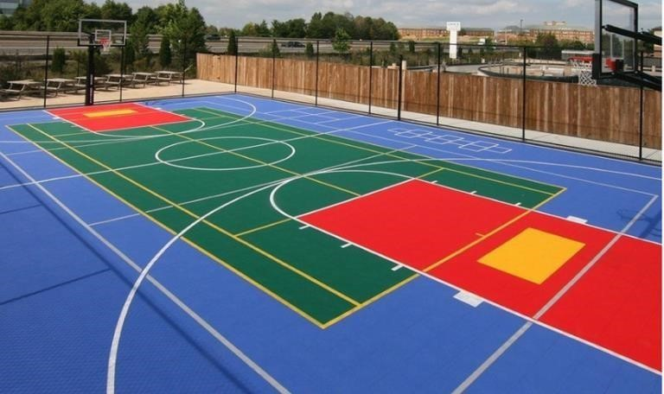

### Figure 1: Conventional sport court

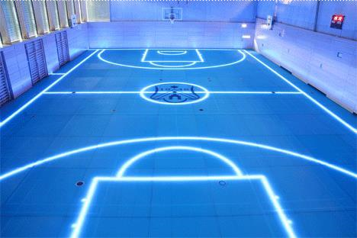

**Figure 2: Auto Generated Line Court**

### 2.10.1 STUDY ON DEVELOPED AUTO GENERATED LINE COURT

This topic discussed about the study on developed an Auto Generated Line Court. Most of the project that used LED was used Arduino microcontroller such as Arduino Uno, Arduino Mega and many more. From that, the author used Arduino Uno for this Auto Generated Line Court project because Arduino Uno is easy, simple and have many references on the internet to refer and study. The author decided to use LED P10 DIP type in Auto Generated Line Court project to display the line. With the code that developed in Arduino IDE software, it helps to connect between Arduino and LED in order to make every type of sports court line appear. To make this Auto Generated Line Court project to be a user friendly is by creating an application. So, there will be a user interaction with the application. From the existing project that discussed above, the project that developed an application was using Blynk or MIT software. For this Auto Generated Line Court project, the author decided to use MIT software to create the mobile application in order to connect the court via bluetooth on the smartphone. This project is helpful to the users as users don’t have to go to multiple places to play different kinds of sports when this Auto generated Line Court provides many sport courts in one place.

## 2.11 CONCLUSION

In summary, this chapter has been exposed to IoT product and literature review on several project that related with this Auto Generated Line Court project. This chapter explained about IoT generally, describe the IoT peripheral like Arduino and the invention of Arduino in every IoT based project. Besides, the author decides to differentiate by comparing the existing project in terms of features, advantages and disadvantages. Every existing project used Arduino microcontroller and LED to create and display the light in many way like shapes or message. Apart from that, this chapter also describe the development from traditional sport court into smart sport court which is the Auto-Generated Line Court project in which the project is more user friendly, smart and safer.

**CHAPTER 3**

**RESEARCH METHODOLOGY**

## 3.1 INTRODUCTION

This chapter describes the process of developing the research methodology required to complete the Auto Generated Line Court for Sport project. The methodology that is used in this study is input-process-output (IPO) methodology. Using IPO methodology, this project will be completed by the desired objective requirement with the guideline provided. This methodology consists of 3 phases which are input, process and output. The content is structured according to the stages of this methodology which is: brainstorming and planning phase, analysis and specification phase, system and band design phase, development phase, implementation phase and the last one is end phase (IMAN et al., 2021).

## 3.2 INPUT PROCESS OUTPUT(IPO) METHODOLOGY

Input process output (IPO) model is a popular way for characterizing the structure of an information processing programme as shown in Figure 3 (Reis, n.d). This methodology is a basic step to help the people who did a project to know their step from the beginning of the project until it is completed. This is the most fundamental form for defining a process in the beginning programming and systems analysis texts (Busbee & Braunschweig, 2018). The term ‘input’ includes all the sources that entered during the project process. It is like an obligation from the environment where the data is gathered to make the process phase work smoothly and transform it into outputs, such as finished goods, services and the desired model. Materials, people or information and resources could be the example of inputs (Curry et al., 2000). Next, ‘process' includes all the variables or factors which enter into the process. The process is computed based on the project specification. It will receive inputs, which will combine and transform into the next phase which is output. Output is the outcome of the project plan’s implementation process to achieve the final product. The output needs to match the desired result according to the objective stated in the project.

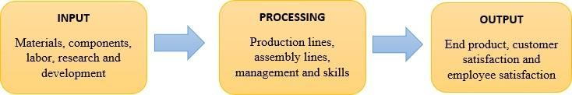

**Figure 3: Input-Process-Output Methodology (IPO) (**Reis, n.d)

### 3.2.1 INPUT

i) Brainstorming and planning phase

The first stage is brainstorming and planning phase. The planning phase, also known as the "Analytical" or "Evaluation Phase," is a phase to define the issue that arose. This is the process of screening, classifying, and merging project criteria, features, and function characteristics as they go from idea to solution. This stage deals with choosing the ideas that are valid to the problem or issue that arose and being analyzed. When the ideas are practical and have a realistic solution, then the project can be approved but it is otherwise when the idea is too unrealistic even though the ideas seem to be sensible (Kaufman et al., 1994). The author analyzed and discussed with the team members to make final decisions on whose ideas to be eliminated and to be chosen that have support in pursuing the ideas further. In order to get the final idea, the author evaluated and looked for the objectives, the pros and cons of the idea. Before advocating an idea, the author looks back to the issue description, goals, and expectations to help in the selection process. A pre-test survey was conducted to gather the data from responses to clarify the issue that has been chosen.

ii) Analysis and specification phase

The next stage is the analysis and specification phase. In this phase, the data that have been collected were gathered to be analyzed. The author evaluated the data and resources for this project such as from the studies, research, journal and others. The evaluated data is important to define the project requirements. An Interview with Mr. Ridzuan, Mr. Afiq and Mr Remiezen from Education Hub Pagoh were conducted to evaluate the selection project as shown in Figure 4. The interview was arranged to present the idea of this project to professionals for identifying whether it is valid or invalid to apply in real life. Some questions were asked regarding the study such as the advantages and disadvantages of this project, an improvement and the professional’s point of view about this project. The response about the project is good, which is the project can be continued and have their approval. Before the meeting ended, they add the improvement that can be added and give some additional suggestions. They also asked the author to study more details about this project. The author discussed the requirements that are needed to achieve an Auto Generated Line Court for Sport that can help the society. The author needs to make sure that the product can react to the selected choice and generate the desired output. Next, the surface of the project’s product needs to be safe and lastly, the product required to successfully act as the line for the court using the LED lights. Based on all of the requirements, then the design was determined.

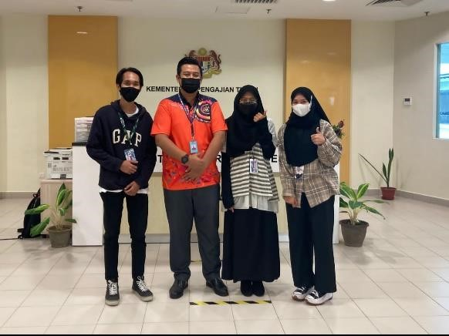

**Figure 4: Meeting with higher ups Pagoh Education Hub**

### 3.2.2 PROCESS

i) System and band design phase

The system and band design phase are the phase where all the requirements need to be transformed into the Design Document which can act as a guide throughout the development phase (TenStep, Inc, 2019). For designing the project, components used play an important role for determining the final design of the project. The equipment or components that will be used is the Arduino Uno Rev3, HC-05 Bluetooth Module, P10 DIP LED lights, and jumper wires for connection. The author has provided a draw circuit in Figure 5 so this circuit can help in visualizing and assembling all the components.

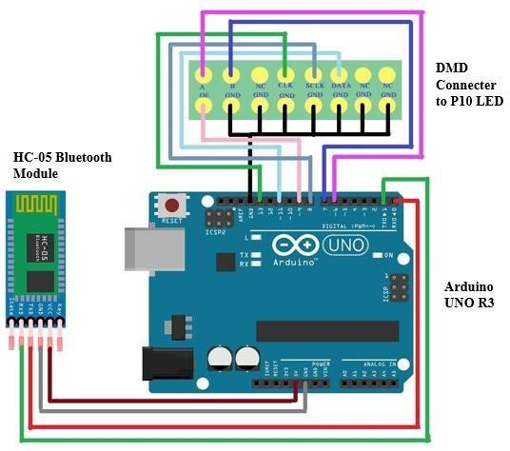

### Figure 5: Circuit Diagram

The Arduino will be used as the main controller of the projects that executes all the codes for this project to be run. The jumper wires connect the LED with the Arduino to act accordingly as the program intended. The designing phase will take place first to make sure the project can be presented in a small consumer model and properly showcase the idea of the project. The next step will be the assembly phase which includes wiring and building of housing for the electronics components to make sure all of it is in one place. The continuation of the process is the coding phase where Arduino IDE are used to code and compile the code into the Arduino. After all the technical aspects have been cleared, the assembly of the projects based on the design planned will take place.

ii) Development phase

The development phase is where the designer and developers begin to work on their project, which seeks to provide a functional product. The product will go through several rounds of development, thus it will have simplistic, minimum functionality. During this phase, the functionality that is needed in this project will be implemented. All the hardware and software that were prepared such as Arduino IDE, MIT application, LED, bluetooth and others were used in this phase. The P10 DIP LEDs are used because the LED density is close so that the display is good, and the P10 LED matrix display can be used to run text and the display has high density so that it can be seen from a distance. (Sungkar & Albab, 2019). The LED will be used to act as a line on the courts which can be changed. The Arduino that is used is a free and open-source prototyping tool with simple hardware and software. Arduino boards can detect inputs such as light on a sensor, a finger on a button, and convert them to outputs such as turning on an LED, triggering a motor, or publishing anything online. By providing a set of instructions to the board's microcontroller, it will tell us what to do. The Arduino programming language (based on Wiring) and the Arduino Software (IDE) (based on Processing) are used to do this. The current arduino that the project used is arduino UNO which has 14 digital I/O pins, can create pulse- width modulated signals, and six analogue inputs that can also be utilised as digital I/O pins. Female 0.10-inch (2.5 mm) headers connect these pins to the top of the board. Commercially available plug-in application shields are also available (Zlatanov, 2016). Arduino IDE are used to compile the code in the Arduino UNO as it is known as a programme that provides a place to code and upload the code so that it can be used to control the project as intended (Arduino, n.d.). HC-05 Bluetooth Module are used to connect application tools for sending the information to arduino so that the control can be done using an application which is much easier. The SFE DMD Connector and Jumper wire is used to connect all technical parts to run smoothly. The last one is acrylic that is used to emit light from LED as a surface.

iii) Implementation phase

This is the phase where it produces the result of the above phases of this project. The author has completed, connected, and fixed the components at the development phase according to the guideline. Iteration testing was performed after connecting all of the components and compiling with code to confirm that the project is working properly and to improve the project. The result was tested and checked to ensure that the developer did the project accurately. Finally, the project was evaluated to ensure that it followed all the guides and the objectives of the project.

### 3.2.3 OUTPUT

**i)** End phase

The last phase is the end phase that is considered as the output of the project. This phase is a phase where the outcome performance was tested. The output section of this project is the completed prototype of this project that works as intended. Initial testing will take place first before displaying the project in public in order to trace early errors or bugs. The final assurance needs to be applied so that it is completed perfectly.

## 3.3 CONCLUSION

The overall conclusion is this chapter explains the detail about the working process of developing step by step of the project. The step that is shown is accomplished as to the requirement needs. Using the Input-Process-Output (IPO) methodology, it helped to guide the overall project according to each phase. Input phase helps to take the data collection to use in this project. Meanwhile the most important thing which is the process helps in visualizing and assembling all of the components so that the project will be completed and making the project run smoothly**.** The testing will be done in the output phase which helps in making sure that the project works according to the intended project.

**CHAPTER 4**

**PROJECT DEVELOPMENT**

## 4.1 INTRODUCTION

This chapter will discuss on the development of Auto Generated Line Court project. The project will develop the prototype of the smart sports court and the system behind it as well in order to function. The functionality of this project is by producing and implementing the code which will be shown in this development phase.

## 4.2 PROJECT HARDWARE

There are several hardware components that were used in developing this project. The components are:

* Arduino UNO

* P10 DIP Light Emitting Diode (LED)

* HC-05 Bluetooth Module

* SFE DMD Connector

* Jumper Wires

## 4.3 ARDUINO UNO CODE DEVELOPING

In this project, the developer chose to use Arduino UNO as the main board. The code will be developed using Arduino IDE Software that can be downloaded from Arduino website on the Internet. After the codes have finish, the code will be executed by uploading the code inside

Arduino UNO and Arduino UNO will be sent the information to the P10 LED to light up the led.

Below figure shows the entire code of the Auto Generated Line Court project.

The codes in Figure 6, Figure 7 and Figure 8 shows the code that will be executed when user click the button in the application. The selection control structure has been applied in this code. For example, if users want to select basketball, then the first if statement will be executed while others will be ignored. Numbers inside the DMD writePixel() shows the line of which row and column will be executed. While the 0 and 1 is a binary number that symbolize as ‘OFF’ for 0 and ‘ON’ for 1 for that specific row and column. This binary number is to specify whether to light up the led or not. This code is applied to every sport in the system.

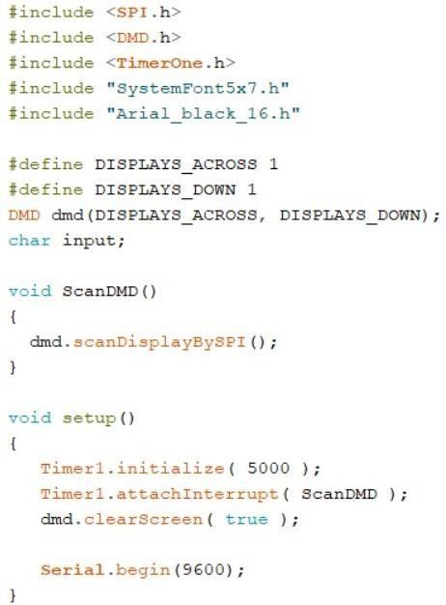

**Figure 6: The library, variable declaration, and function.**

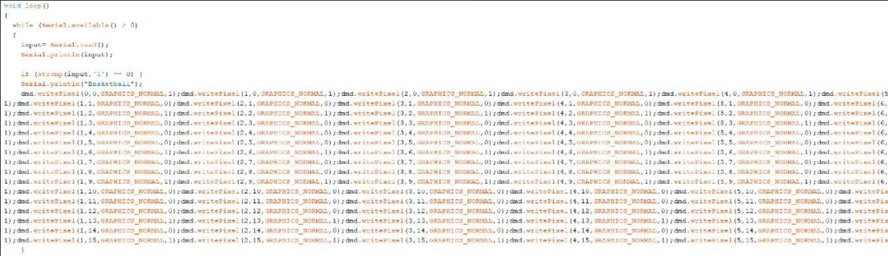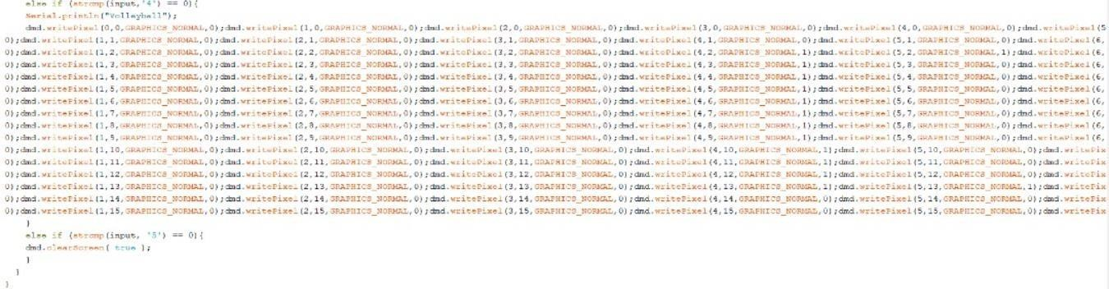

**Figure**

**7:**

**Arduino**

**codes**

**scripts**

**sports**

**Figure**

**8:**

**Arduino**

**codes**

**scripts**

## 4.4 MIT APPLICATION

For this project, the developer chose an MIT application to develop a mobile application. The mobile application is for users in order to connect the court. To connect the court, the developer used bluetooth to connect Arduino UNO with MIT app. The coding for the interface that used

MIT application is shown in Figure 9. The name of this mobile application is “Auto-Generated

Line Court Remote”. The application contained five buttons for four different sports which is badminton, basketball, tennis, volleyball, and one clear court button to end the system as shown in Figure 10.

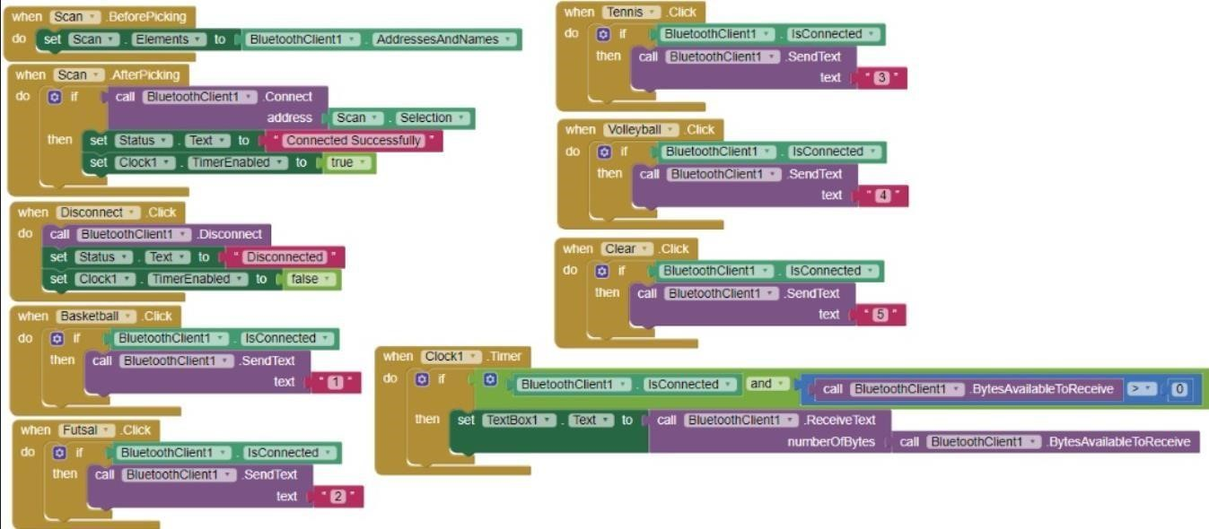

### Figure 9: MIT codes

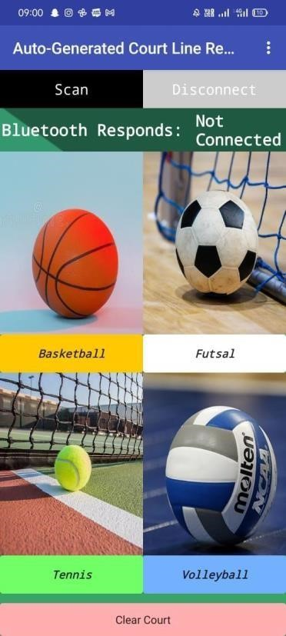

**Figure 10: Application interface**

## 4.5 SPORTS COURT MODEL

# Table 2: Item list

|  |  |  |
| --- | --- | --- |
| **No.** | **ITEM** | **QUANTITY** |
| 1 | P10 DIP Light Emitting Diode (LED) | 1 |
| 2 | HC-05 Bluetooth Module | 1 |
| 3 | SFE DMD Connector | 1 |
| 4 | Arduino Uno | 1 |
| 5 | Jumper Wire | 1 |
| 6 | Transparent acrylic | 1 |
| 7 | Frame | 1 |

There were several items that were involved in this process and every component is combined together. The items that used can be seen in Table 2. This prototype model was built to demonstrate on how this Auto Generated Line Court work briefly. The prototype can be seen in the Figure 11 below.

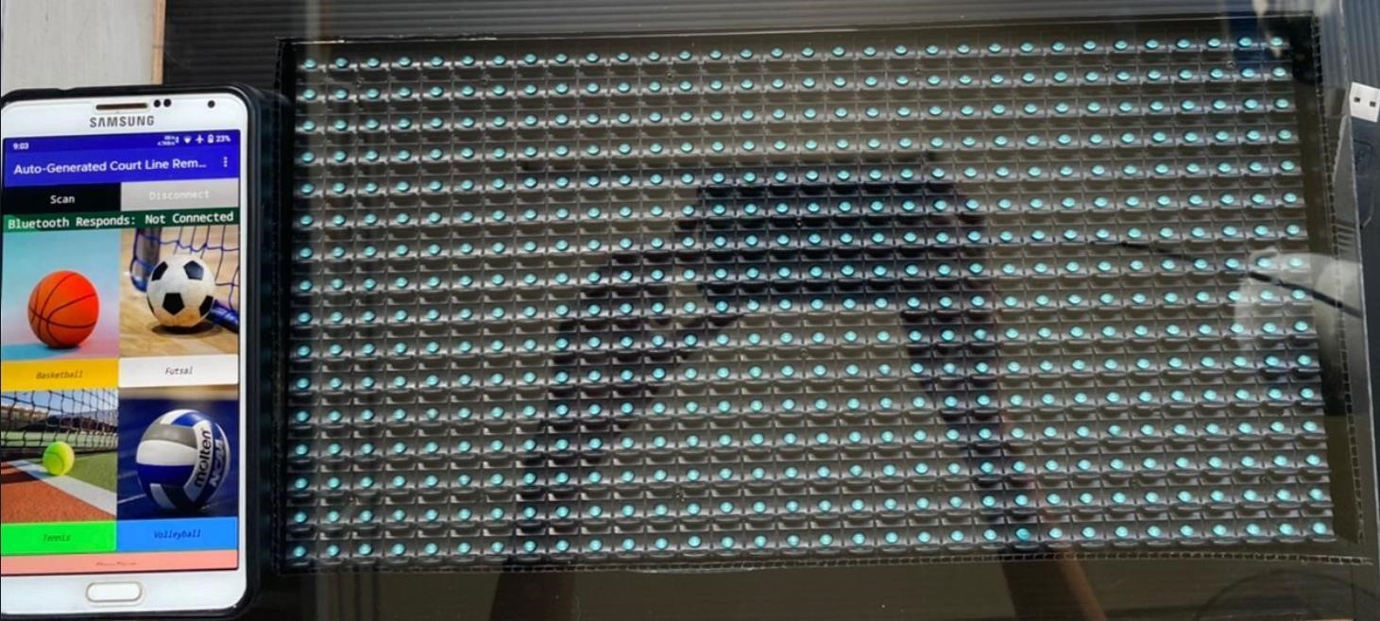

**Figure 11: Product prototype**

## 4.5 CONCLUSION

In conclusion, in this development phase of the project have covered every step in developing the project in terms of prototype, coding and mobile application. This phase was the most important and tricky part because there were many try and error processes in order to make this product successfully function. Once the development of the project has done, the test or checking process will be performed and this phase will be explained in the next chapter.

**CHAPTER 5 RESULT AND DISCUSSION**

## 5.1 Introduction

This chapter discussed the testing results of the project prototype. First, the author self- tested the project prototype to see if the prototype work well with the intended function. Then, the author continued the testing with the higher ups of Pagoh Education Hub which is from Youth and Sports department to test and evaluate the prototype from their perspective. A question-and- answer session also was conducted via google form to get the feedback from responses. Through this testing, it will determine the functionality and effectiveness of the prototype so that the project accomplished successfully together with the objectives required. The results are evaluated after the testing of the prototype.

## 5.2 Testing

The testing phase is very important to develop a complete and functional project. The authors test the prototype to make sure that it is functional together followed by the objectives required. Basically, the author tested all the electrical components first (bluetooth, arduino, LED, DMD and jumper wires), whether the components succeeded as required. After completed testing is made, the authors tried to connect the prototype with the application that they made using MIT Application. The reason to test out is to make sure that the application is connected via bluetooth and the bluetooth can receive all the information needed.

# Table 3: Result according to the item and function

|  |  |  |
| --- | --- | --- |
| **Item** | **Function** | **Result** |
| P10 DIP Light Emitting Diode (LED) | To generate the line that have been coded | The specific line that have been coded are generated |
| HC-05 Bluetooth Module | To connect with the application and receive the  information | The bluetooth successfully received the information from  the application |
| SFE DMD Connector | To connect the arduino with  LED | The arduino and LED are connected |

|  |  |  |
| --- | --- | --- |
| **Item** | **Function** | **Result** |
| Arduino Uno | To execute the code on  Arduino IDE and interact with sensors’ input and output | The Arduino interacted with the sensor and the code  effectively |
| Jumper Wire | To connect the arduino with  LED, and arduino with bluetooth | The arduino, LED and bluetooth are connected |
| Transparent acrylic | To emit the light from LED  P10 to act as a surface for the line | The acrylic are able to act as the surface for the line |
| MIT Application | To build application for the project interface | The application which named Auto Generated Court Line  Remote are working perfectly fine as intended |

The authors continued to test the prototype with acrylic to make sure that the acrylic can act as a surface for the generated line. The testing results are shown in Table 3 according to the item and function. The testing procedure continued to be carried out to make sure the prototype not only functions well in sending and receiving data or it can be used, but this testing needs to be done completely to make sure all the items succeeded to produce the final output that met the objectives required. Firstly, the authors prepared the electrical components and the Auto Generated Court Line Remote application via smartphone that have been tested before. Next, the Auto Generated Court Line Remote application and the bluetooth connection were tested to see if the connection is working properly by pressing the button Scan at the interface. Figure 12 shows the connection between bluetooth and the application to be paired. Figure 13 shows that the bluetooth responds are “not connected” because the author does not pair it with the device. After the author have paired it, the bluetooth responds in the application are written as

“Connected Successfully” and there will be a reaction on the bluetooth which it would blink twice to show the connectivity because the application and the bluetooth are able to connect and interact with each other as shown in figure 14.

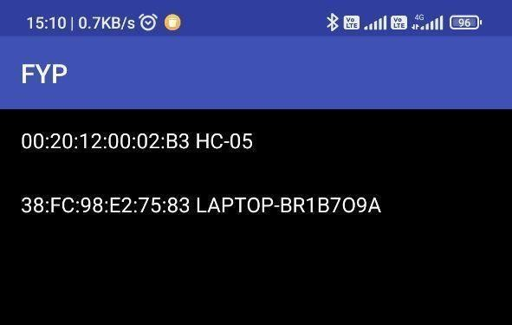

## Figure 12: Connectivity between bluetooth and application

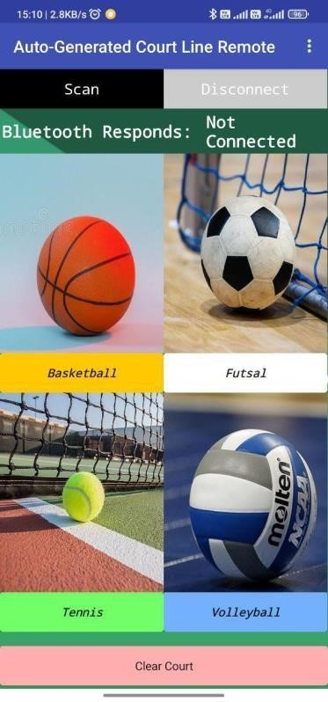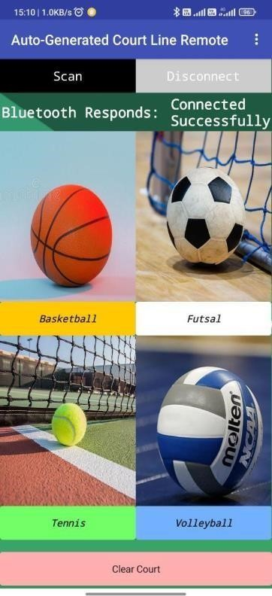

|  |  |
| --- | --- |
| **Figure 13: Bluetooth Responds:** | **Figure 14: Bluetooth Responds:** |
| **“Not Connected”** | **“Connected Successfully”** |

# Table 4: Result according to the button and output

|  |  |
| --- | --- |
| **Button** | **Output** |
| Basketball |  |
| Futsal |  |

|  |  |
| --- | --- |
| Tennis |  |
| Volleyball |  |

|  |  |
| --- | --- |
| Clear Court |  |

The testing is continued with the interaction from the application and bluetooth is completely successful as for the data itself. The authors start with pressing the button basketball, followed by futsal, tennis and volleyball. The result of the pressed button and output are shown in Table 4. After the author finished testing all the court features on the application, the author disconnected from the application because it no longer wanted to be used. So, the author pressed the Disconnect button and the bluetooth responds will be written as “Disconnected” as shown in Figure 15. From this testing, the developer analyzed that all the functions on the prototype are working well as intended. The authors have succeeded in the testing stage to achieve the exact result that met the objectives of the project.

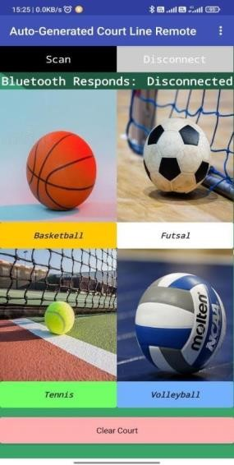

## Figure 15: Bluetooth Responds:” Disconnected”

After the project prototype have functioning well as intended, the author then conducted a meeting with the higher ups that specialized in youth and sports department. First, the author presented and briefed about the project and then showed them the completed prototype from start until the intended output is generated. After presented to them, they evaluated the overall project and give suggestions for improvements as shown at Figure 16 below. Next, author then conducted a question-and-answer session via Google Form to get the feedback about this project as shown at Figure 17 below. The purpose of this study is to generate multiple lines in a court using LED lights.

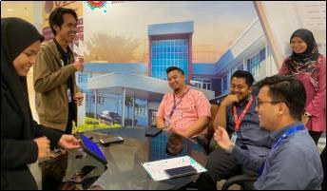

## Figure 16: Meeting with higher ups for testing

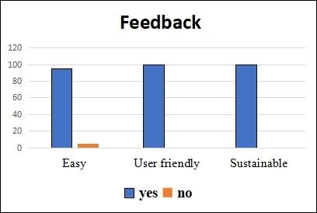

## Figure 17: Feedback via google form

### 5.3 Discussion

The Auto-Generated Line Court for Sports which is the studies of this project are mostly focused on the output that generated from the prototype. All the components and software have reacted as intended which produce the desired result which is the desired court’s line with selected choice. The multiple line that is produced in a surface has proven that the Auto-Generated Court for Sports project is useful and efficient to be used by the target group which is for kids, adults and citizens of all kinds or groups of people. This efficiency provides a convenient place to play sports which can save cost and space. The interface for the Auto Generated Court Line Remote application also is easy to use as the feature itself is understandable.

From the meeting that was conducted, the evaluator concluded the author projects as a successful project and give insightful comment such as this project need to be checked if it is follows the rules and regulation for sports. The overall respondents concluded that this project is easy, user friendly and sustainable. An opinion question also was asked regarding the project which is if the respondent like the idea of the smart court and any improvement for the future. Mr. Mohd Ridzuan Bin Md Kasmani, which is one of the respondents, agreed that he like the idea of this court and for the improvement, he suggest that more research need to be conducted from every aspect so that this project would be accepted and implemented.

### 5.4 Conclusion

This stage is proven that it is important to determine that the project is working properly as intended and generate required output. The testing and results are all described in this chapter to prove that this project prototype is accomplished successfully together with the objectives. The developer evaluates the functionality and effectiveness of the project prototype by testing and discussing the project prototype. Through all the testing, the project is working perfectly fine and mostly, the required output is strongly achieved by the authors.

**CHAPTER 6**

**CONCLUSION**

## 6.1 INTRODUCTION

This chapter would conclude the overall process of the project. The idea of the development of auto-generated line court was from the problem that people encounter when they used the normal sports court. This project was an innovation on the traditional sports court. Therefore, this chapter would discuss the achievement, the constraints, and the improvement of the project in order to produce a greater outcome.

## 6.2 PROJECT ACHIEVEMENT

After all the hard work to develop this project, the project finally achieves the goals of the objective stated earlier in this report. Finally, auto-generated line court had successfully developed efficiently and ready to use by people.

**Objective 1: To develop an Auto-Generated Line Court for Sports using Arduino that reacts to the selected choice and generates the desired court’s line.**

The author did many times of tried and errors in the coding part for Arduino. Arduino was the most important part in order to make the P10 LED function. The author did many researched on the Arduino codes, MIT codes for the application to controlled and chose the sports line remotely and the led itself. From this researched, users were able to select the sports line that they wanted, and the court’s line was able to generate based on the chosen sports.

**Objective 2: To establish a safe and durable surface of the glass court developed by using security glass as the material of the court.**

There were various glasses for sports purposes, but security glass was more suitable for this project. The author did a lot of researched in choosing the typed of glass to use for the sports court surface and finally chose security glass as the court floor surface. The acrylic glass that was used for the project prototype was to represent the security glass. Glass surface was better in terms of safety and durability as the glass surface could reduce the injuries and less maintenance needed

**Objective 3: To evaluate the developed Auto-Generated Line Court for sports.**

The development of the auto-generated line court was tested and evaluated from its prototype. The design and every component of the project was neatly organized in ordered to present to the developer. The project was tested in terms of functionality, efficiency, and the design as well. The developer found that this project was a good idea in reducing the space and easy to use even for the first time used.

## 6.3 PROJECT CONSTRAINTS

During the process of developing this project, the author had been faced few problems and challenges which was:

1. Struggling with the coding part which was the Arduino codes since this was the first time using Arduino board and Arduino software which used C++ language to program the IoT product. Therefore, this process was very time-consuming as the author did a lot of tried and error and did many of researched in ordered to get the desired output for this project

1. Difficulties in producing line shape on the LED board. After so many times of try and error, the author finally found the problem which was the first LED board (P10 SMD) was not suitable for working with displaying the shapes. So, the author changed it to LED P10 DIP type board and the problem was solved as the new led board was able to display the desired output.

1. The DMD connector component was loose which made the output of the led p10 board was not properly display. Therefore, the solution was the author bought a new DMD connector in order to get proper output
2. The P10 LED board was not reacting or displayed the line when the button on the application was clicked even though the Bluetooth was already connected to the P10 LED. So, the author tried to find and fix the code error on the application software platform named MIT.

1. Time consuming because the author had to waited for the electric component to arrive. The author could not proceed in developing the project until all component was arrived. This had affected the project timelines.

## 6.4 PROJECT IMPROVEMENT

After the development of this project, there were a lot of improvements that could be done in this project in order to get a better and more efficient product. The improvement that could include in this project were:

1. Include a sensor like a passive infrared (pir) sensor in the court surface to detect the motion of people and turn off the LED when there was no motion of people detected. This also would work when the user forgot to turn off the application when they finished using the court.

1. Include moving sports equipment like basketball hoops by using motor to move when users click basketball button on the application. So, users do not have to took out and put the sports equipment back into the hall store.

1. The auto-generated line court could add security in which only people in the hall were able to use the court by inserting a unique code on the application when they wanted to use the court. So, people outside or near the hall could not been able to use the application.

1. Add a score pointed board at the court that could been controlled remotely via smartphone on the application. This helps the player to know their score without even count manually by themself.

## 6.5 CONCLUSION

Auto-generated line court was a project that aims to ease the users into doing sports. In this chapter, the author had to faced and solve many problems or constraints of the project. Also, the author was able to achieve those objectives excellently. The author hopes that this prototype which was an innovative IoT product could been able to fit the requirement to become a real product in the market one day that actually could help to eased and encouraged people in doing sports.

**REFERENCES**

Sunil Kumar, K. N., Nataraja, N., Avinash, J. L., Rajendra Prasad, P., Santosh Kumar, S., &

Arjun Kumar, G. B. (2020). Design of LED’s for Interactive Court Lines. 2020 International

Conference on Recent Trends on Electronics, Information, Communication & Technology

(RTEICT). https://doi.org/10.1109/rteict49044.2020.9315667

Surendiran, D. S., Mathumathi, M., Nivetha, S., &amp; Lucina, A. P. (2020). IOT BASED MESSAGE SCROLLING LED DISPLAY. International Research Journal of Engineering and Technology (IRJET), 07(05)

Sungkar, M., &amp; Albab, U. (2019). Pembuatan aplikasi Android Score Board led Matrix P10

Berbasis Arduino STM32 Kendali Android. Power Elektronik: Jurnal Orang Elektro, 8(1), 5–

9. https://doi.org/10.30591/polektro.v8i1.1497

Jeyavinotha, S., Deepika, B. P., Remya, R., Ajin, N. V., &amp; Ajin, N. V. (2019). Design of automation system to control the brightness of LED using Arduino Uno and IOT. INTERNATIONAL JOURNAL OF RECENT TRENDS IN ENGINEERING &amp;

RESEARCH, 05(Special Issue 07), 247–250. https://doi.org/10.23883/ijrter.conf.20190304.043.lowsn

Marinissen, E. J., Zorian, Y., Konijnenburg, M., Chih-Tsun Huang, Ping-Hsuan Hsieh, Cockburn, P., Delvaux, J., Rozic, V., Bohan Yang, Singelee, D., Verbauwhede, I., Mayor, C., van

Rijsinge, R., & Reyes, C. (2016). IOT: Source of test challenges. *2016 21th IEEE European Test Symposium (ETS)*. https://doi.org/10.1109/ets.2016.7519331

Hilary Omatule, O., Hassan-Enua Mshelgaru, I., & Mhya Andrew, S. (2015). Maintenance

Generators and Procurement Methods of Sport Facilities in the North Central

Nigeria. *Engineering Management Research*, *4*(2). doi: 10.5539/emr.v4n2p21

Bugaj, S., &amp; Kosiński, P. (2018). Thermal comfort of the sport facilities on the example of indoor tennis court. IOP Conference Series: Materials Science and Engineering, 415, 012024.

https://doi.org/10.1088/1757-899x/415/1/012024

El-Abd, M. (2017). A review of embedded systems education in the arduino age: Lessons learned and future directions. International Journal of Engineering Pedagogy (IJEP), 7(2), 79.

https://doi.org/10.3991/ijep.v7i2.6845

KAKADE, S. R., BUTALE, R. G., &amp; GUPTA, S. U. C. H. I. T. A. V. (2018, January).

Automation of greenhouse using Arduino and GSM module . ResearchGate. Retrieved

February 2018, from

https://www.researchgate.net/publication/343306240_Automation_of_Greenhouse_Using_Ard uino_and_GSM_Module

Zlatanov, N. (2016, March 10). Arduino and Open Source Computer Hardware and Software.

ResearchGate. Retrieved 2015, from

https://www.researchgate.net/publication/312168672_AC_Power_Distribution_Systems_and _Standards

Yusro, M., Guntoro, N. A., &amp; Rikawarastuti. (2021). Utilization of microcontroller technology using Arduino Board for internet of things (a systematic review). THE 2ND

SCIENCE AND MATHEMATICS INTERNATIONAL CONFERENCE (SMIC 2020):

Transforming Research and Education of Science and Mathematics in the Digital Age.

https://doi.org/10.1063/5.0041705

Ying, K. J., Woei, L. X., &amp; Wen, L. H. (2020). iWalk: Smart Walking Show For Visually Impaired People.

Kumar, N., Vijayalakshmi, B., Prarthana, R., & Shankar, A. (2016). IOT based smart garbage alert system using Arduino UNO. 2016 IEEE Region 10 Conference (TENCON). doi: 10.1109/tencon.2016.7848162

Fleming, W. J. (2001). Overview of automotive sensors. IEEE Sensors Journal, 1(4), 296–308.

https://doi.org/10.1109/7361.983469

Iman, N., MOORTHY, J., & SINNATHAMUDHU, J. (2021). SMART HEART BAND; THE DEVELOPMENT OF EFFECTIVE EMERGENCY BAND.

Asghar, M. H., Negi, A., &amp; Mohammadzadeh, N. (2015). Principle application and vision in internet of things (IOT). International Conference on Computing, Communication &amp; Automation. https://doi.org/10.1109/ccaa.2015.7148413

Moore, S. J., Nugent, C. D., Zhang, S., &amp; Cleland, I. (2020). IOT Reliability: A review leading to 5 key research directions. CCF Transactions on Pervasive Computing and

Interaction, 2(3), 147–163. https://doi.org/10.1007/s42486-020-00037-z

Lazaro, A., Villarino, R., &amp; Girbau, D. (2018). A survey of NFC sensors based on energy harvesting for IOT applications. Sensors, 18(11), 3746. https://doi.org/10.3390/s18113746

Harris III, A. F., Khanna, V., Tuncay, G., Want, R., &amp; Kravets, R. (2016). Bluetooth low energy in dense IOT environments. IEEE Communications Magazine, 54(12), 30–36.

https://doi.org/10.1109/mcom.2016.1600546cm

Gupta, P., &amp; Chhabra, J. (2016). IOT based smart home design using power and security management. 2016 International Conference on Innovation and Challenges in Cyber Security

(ICICCS-INBUSH). https://doi.org/10.1109/iciccs.2016.7542317

Arduino. (n.d.). Arduino - Introduction. Retrieved July 20, 2021, from https://www.arduino.cc/en/guide/introduction

Monica, E., Khairunniesha, & Najiha, M. (2020). Smart Ventilation For Home.

Kaufman, J. J., & Carter, J. L. (1994). *Evaluating brainstorming ideas: "The making or breaking of the ve workshop"*. CiteSeerX. Retrieved from https://citeseerx.ist.psu.edu/viewdoc/summary?doi=10.1.1.202.1457

**APPENDIX A**

Table A.1: Gantt Chart

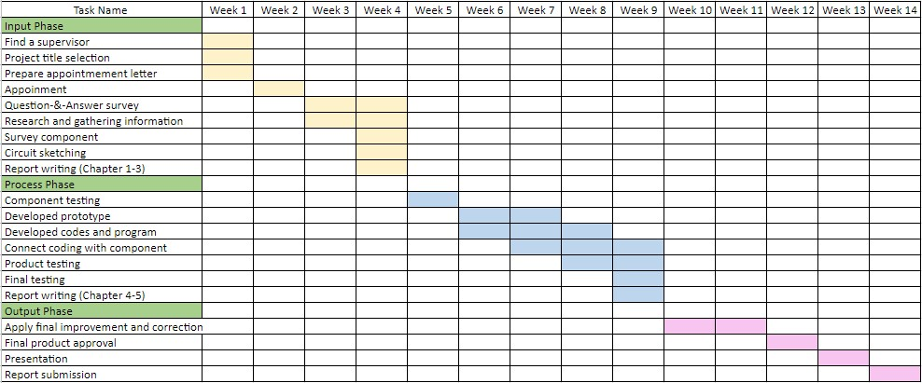

**APPENDIX B**

Table B.1: Feedback Evaluation Survey Form

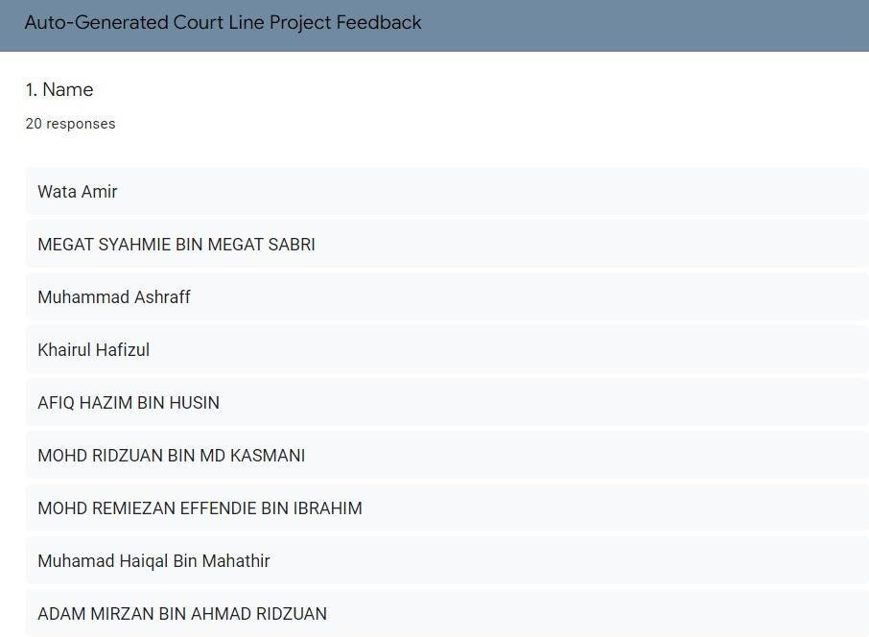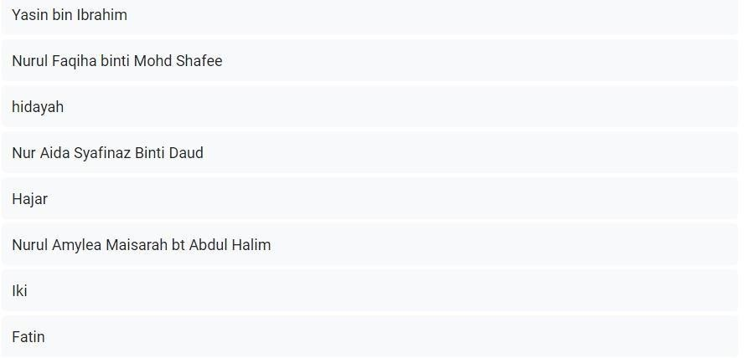



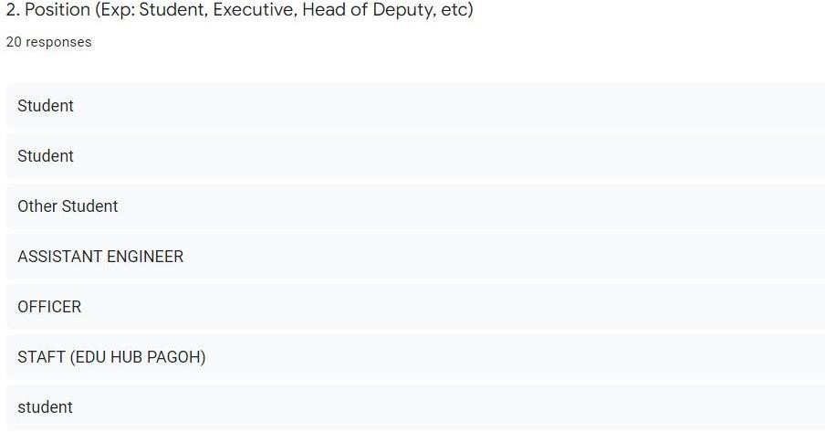

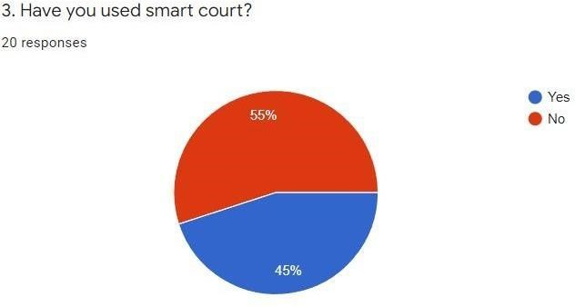

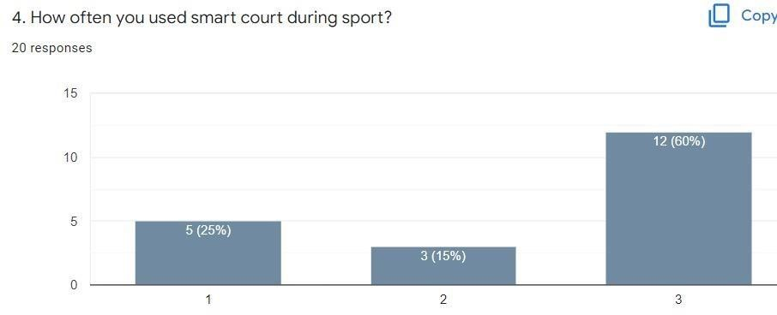

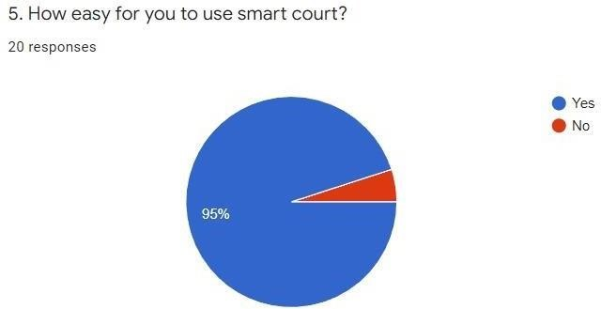

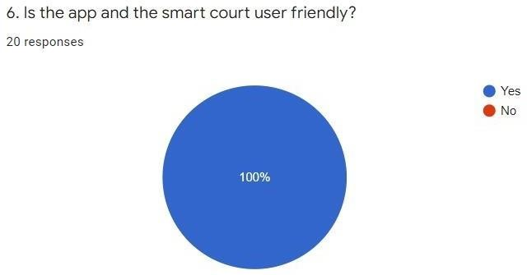

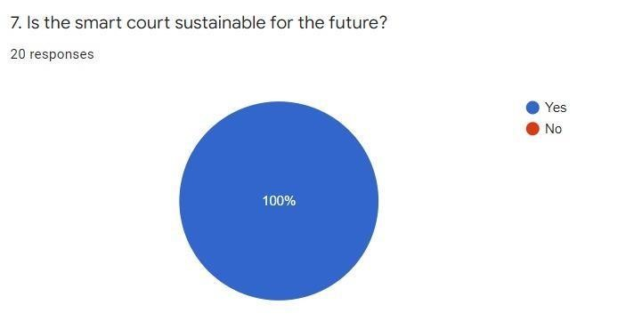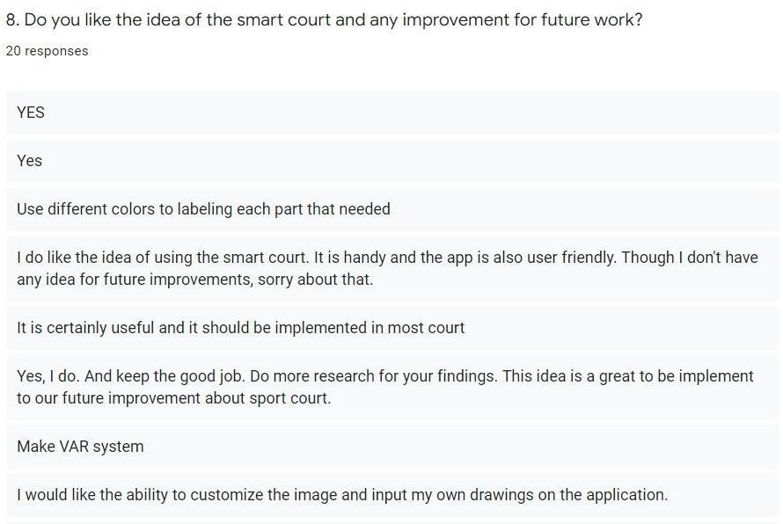

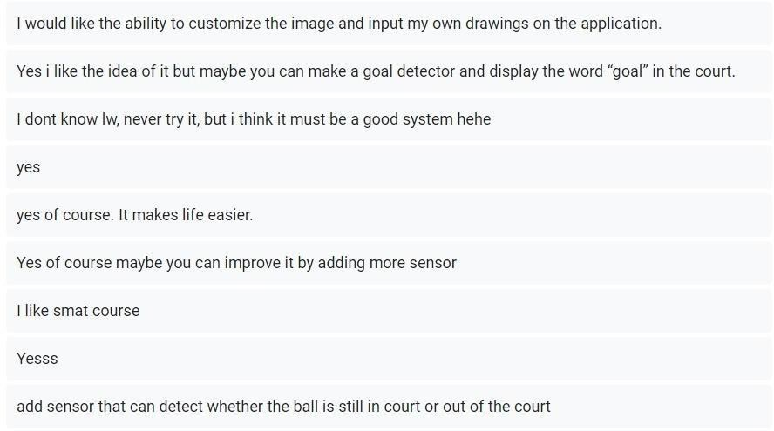

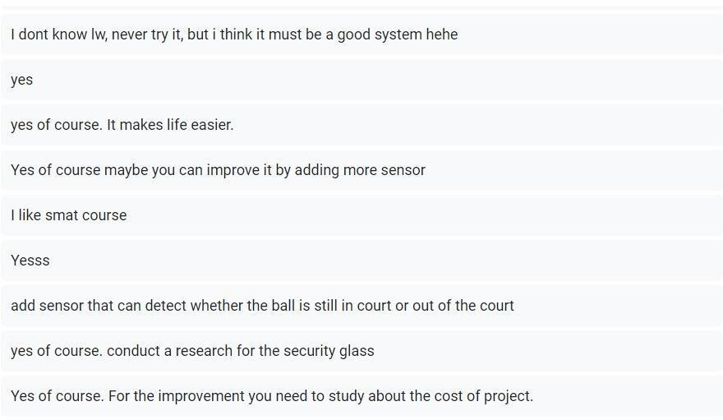

**APPENDIX C**

Table C.1: Product Cost Table

|  |  |  |  |
| --- | --- | --- | --- |
| **Components** | **Total Piece** | **Price in RM (per piece)** | **Total Price in RM** |
| P10 DIP Light Emitting Diode (LED) | 1 | 1.00 | 1.00 |
| HC-05 Bluetooth Module | 1 | 9.40 | 9.40 |
| SFE DMD Connector | 1 | 1.50 | 1.50 |
| Arduino Uno | 1 | 3.42 | 3.42 |

|  |  |  |  |
| --- | --- | --- | --- |
| Jumper Wires | 10 | 0.20 | 2.00 |
| Transparent acrylic | 1 | 0.20 | 0.20 |
| TOTAL ALL COMPONENTS |  |  | 42.42 |